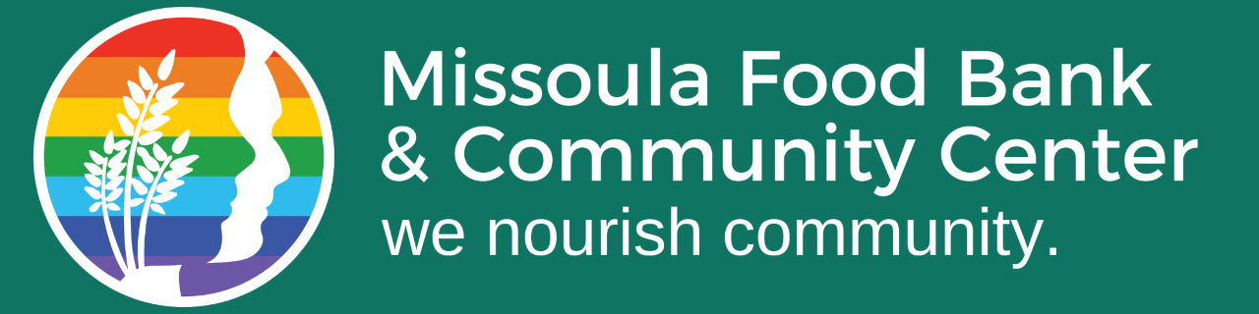
Campus Compact AmeriCorps Summer Staff
Position dates: June 3-August 12, 2024
Missoula Food Bank & Community Center seeks AmeriCorps summer staff to help ensure success of the summer Kids Table program. The AmeriCorps staff help supervise and support volunteers in preparing meals for community families. The AmeriCorps staff will lead an open meal site, including: planning and implementing engagement activities, connecting families with additional resources, providing a safe place for children, and supervising volunteers who assist at meal sites.
Missoula Food Bank & Community Center is a non-partisan, anti-racist, LGBTQ2s+ ally organization. All service members sign a Code of Conduct agreeing to behave in accordance with these values while serving as part of our team.
Weekly activities:
- Support summer meal sites through meal distribution and engaging participants, 2-5 hours each day (40%).
- Lead and support volunteers in meal production, 2-4 hours each day (40%)
- Organizational reporting and record keeping, developing engagement programming, attending trainings and meetings, 2-3 hours each week (10%)
- Support other services offered by MFB&CC: store and pantry services, twice monthly senior and homebound individual’s home-delivery nutrition programs, and weekly distribution of weekend backpack program, 1-2 hours each week (5%)
- AmeriCorps meetings and reporting, 1 hour each week (5%)
Benefits:
- Living allowance of $2,823 paid by AmeriCorps Campus Compact
- End-of-service Education Award of $1,459.26. Eligible for Education Award matching programs at many Colleges and Universities.
- Option for temporary hire by Missoula Food Bank & Community Center with same job duties May 27-June 2 and August 12-27 at $15/hour
- No work June 19th in honor of Juneteenth, or July 4-5th in honor of Independence Day
- Daily one hour paid lunch break, with lunch provided
- Professional development and training opportunities
- Possible internship credit, if desired
Available positions: 5
Please submit a Resume and Cover Letter to aclark@missoulafoodbank.org by April 22, 2024
Visit the Campus Compact Montana website for more program information.

