50 Most Affordable Online MPH Programs 2015
By Iris Stone
Posted August 2015
Online MPH programs can be particularly advantageous for busy adults. Whether you’re a health practitioner or completely new to healthcare, many schools will welcome you into their MPH degrees online without requiring any campus visits or face-to-face sessions. This particular article focuses on the most affordable online MPH programs available in 2015.
A career in public health is an attractive option for several reasons; the field is broad, diverse, and growing, and is perfect for people who are interested in helping others. Unlike careers in medicine or nursing, which are inherently quite specific, public health opens the door to a range of job opportunities. An MPH in particular can do wonders for your career prospects – by adding a graduate-level distinction to your resume, you’ll be eligible for work in epidemiology, biostatistics, social work, research, academia, education, promotion, management, volunteerism, clinical matters…the list goes on.
For this particular article, we started by initiating a thorough search for public health programs. We used College Navigator and Google to search, check, and confirm a list of all the public health master’s degrees in the United States that are offered via distance education. To clarify, this means that we only considered full graduate programs (not certificates) that are available 90% or more online (a few campus visits for seminars or workshops were acceptable, but “hybrid” programs and ones with regular face-to-face sessions in the curriculum were not).
Lastly, we used College Navigator to collect each school’s tuition rates for their graduate programs, as well as to determine the associated fees for attendance. For the purposes of creating a ranking, we averaged each public school’s in-state and out-of-state rates to determine a single approximate cost – although if they made the cut, we included both rates for the benefit of our readers. The 50 most affordable schools are described below, listed alongside their projected annual cost. For simplicity’s sake, we combined tuition and fees into a single value, but please note that in nearly all cases the fees account for only a small portion of the total price.
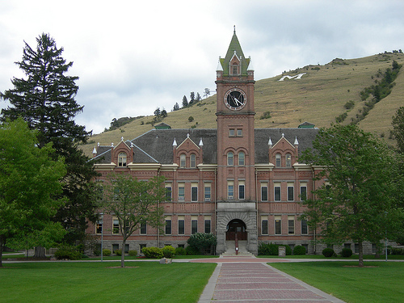

16. University of Montana - Master of Public Health
The rigorous, 42-credit MPH at the University of Montana is comprehensive to say the least – it requires a professional paper, practicum, full portfolio, and six elective credits in addition to numerous core courses. Skill development focuses on communication, leadership, health promotion, and problem-solving abilities, while class discussions help students collaborate on creative ways to address contemporary problems in the field. The university also offers a certificate of public health, and collaborations with the physical therapy, pharmacy, and human performance programs make it easy for students to mix multiple areas of interest.
Tuition and Fees: $5,765/yr (In-state) $19,297/yr (Out-of-state)

